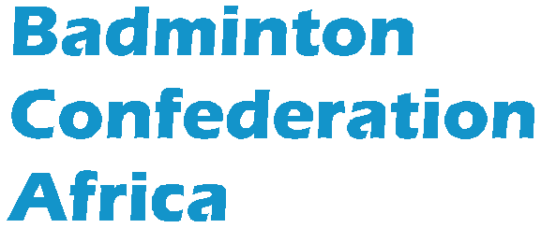
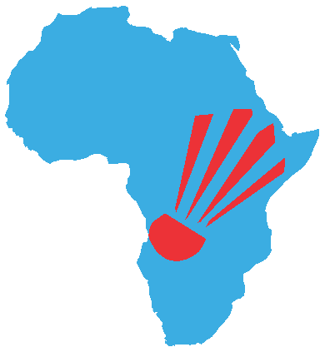

ONLINE UMPIRES COURSE 2020
ROAD TO BCA ACCREDITATION
Oct to Dec 2020

NOMINATION FORM

Country

October 2020
 | National Umpire -1 (Male) | National Umpire -2 (Female)
Name
Email Address
Date of Birth
Date of National Accreditation

November 2020
 | National Umpire -1 (Male) | National Umpire -2 (Female)
Name
Email Address
Date of Birth
Date of National Accreditation

December 2020
 | National Umpire -1 (Male) | National Umpire -2 (Female)
Name
Email Address
Date of Birth
Date of National Accreditation

Please complete the form and send it to s.edoo@badmintonafrica.com | a.reda@badmintonafrica.com not later than Wednesday 30 September 2020.

Signed by National Association

Name and Position in Association

Signature Date

Seal of Association

